Test Case: tc006_SPX_Dev5_Crear_Requisicion_Spot_Tipo_Cobro_Proyect_Urgent
Step 1 - Enter username and password and click to button Enter: Credentials Entered
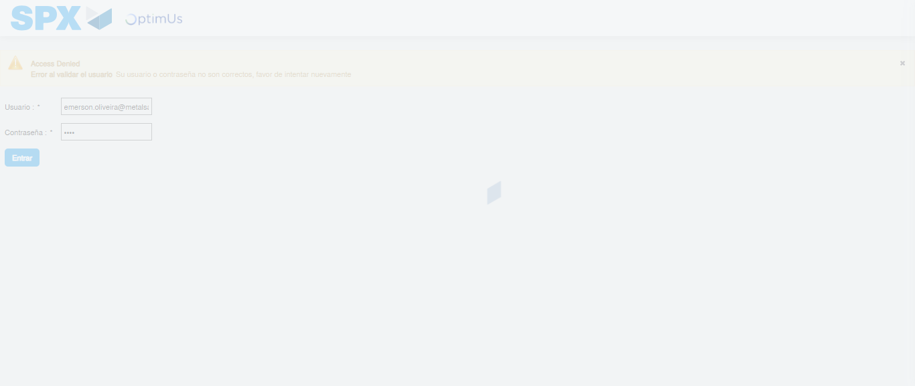Image file-name: QC_Testing-tc006_SPX_Dev5_Crear_Requisicion_Spot_Tipo_Cobro_Proyect_Urgent-1787008872502

Step 2 - Select to UEN and Access to Spot Buy Requisitions : UEN Correctly selected and Correct access
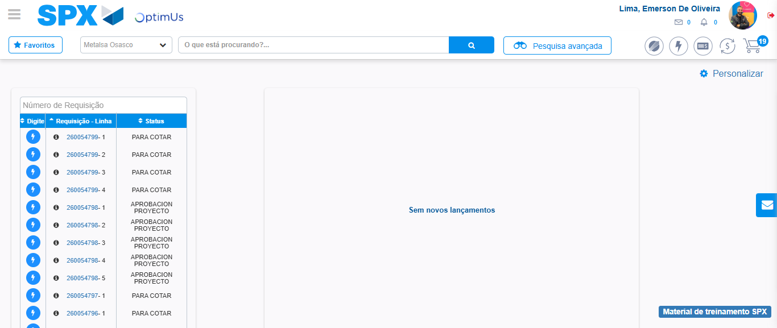Image file-name: QC_Testing-tc006_SPX_Dev5_Crear_Requisicion_Spot_Tipo_Cobro_Proyect_Urgent-1787008899711

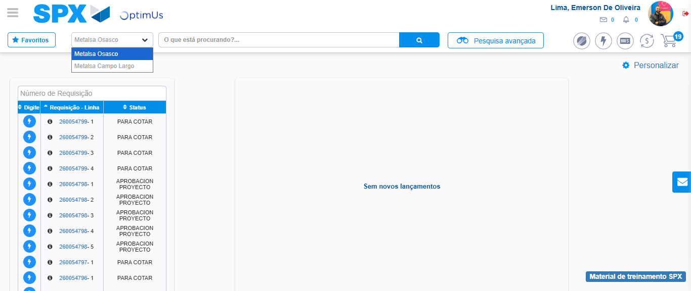Image file-name: QC_Testing-tc006_SPX_Dev5_Crear_Requisicion_Spot_Tipo_Cobro_Proyect_Urgent-1787008902291

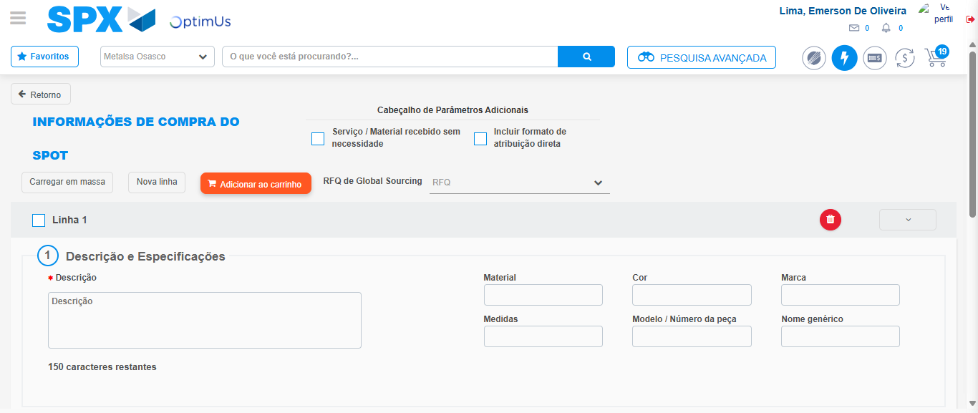Image file-name: QC_Testing-tc006_SPX_Dev5_Crear_Requisicion_Spot_Tipo_Cobro_Proyect_Urgent-1787008922920

Step 3 - Data Capture Spot Buy Requisition: Data captured correctly
Image file-name: QC_Testing-tc006_SPX_Dev5_Crear_Requisicion_Spot_Tipo_Cobro_Proyect_Urgent-1787008923233

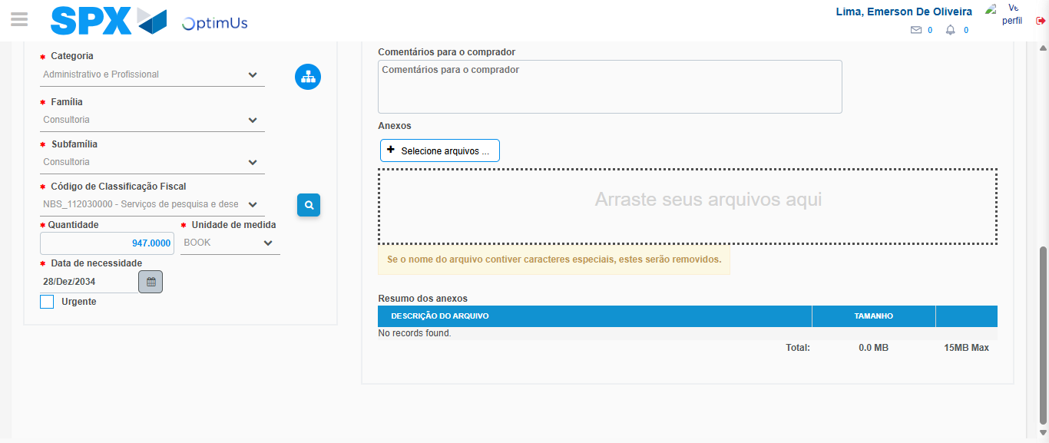Image file-name: QC_Testing-tc006_SPX_Dev5_Crear_Requisicion_Spot_Tipo_Cobro_Proyect_Urgent-1787008942185

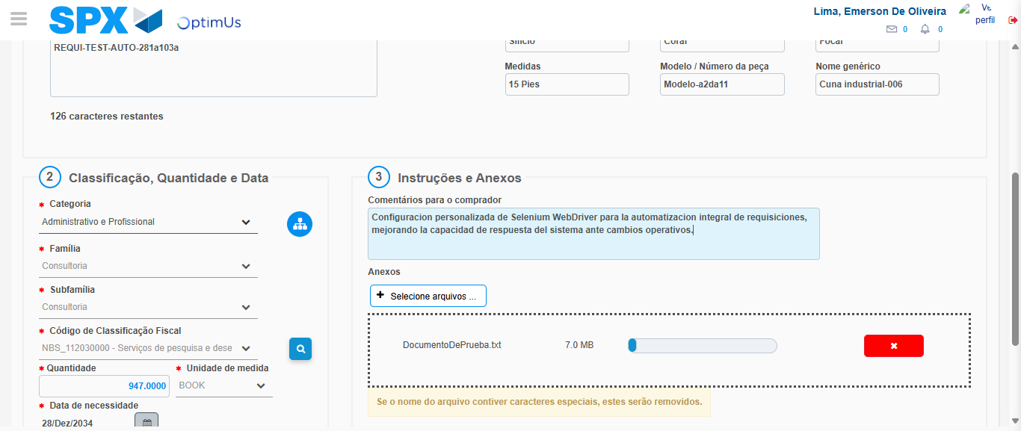Image file-name: QC_Testing-tc006_SPX_Dev5_Crear_Requisicion_Spot_Tipo_Cobro_Proyect_Urgent-1787008943127

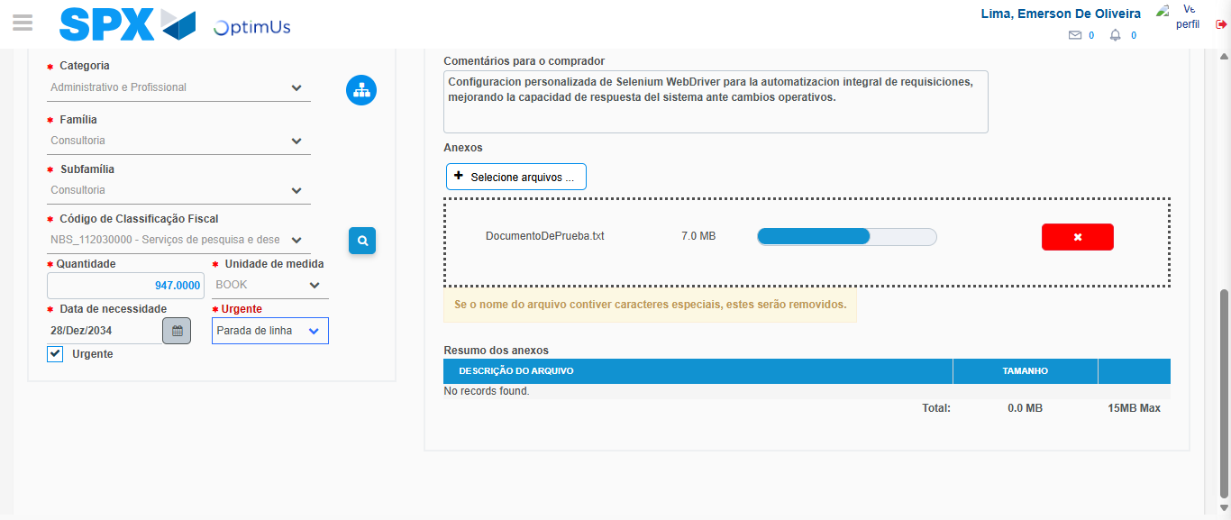Image file-name: QC_Testing-tc006_SPX_Dev5_Crear_Requisicion_Spot_Tipo_Cobro_Proyect_Urgent-1787008946971

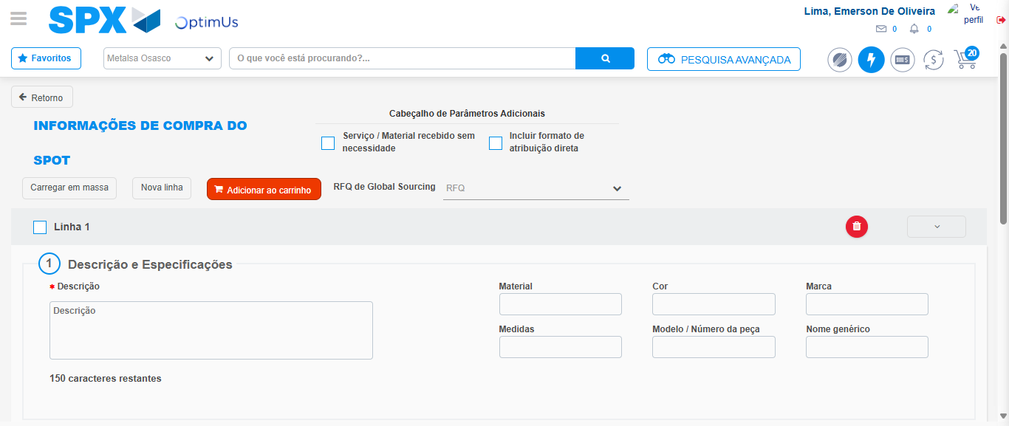Image file-name: QC_Testing-tc006_SPX_Dev5_Crear_Requisicion_Spot_Tipo_Cobro_Proyect_Urgent-1787008957716

Step 7 - Return to Main Page SPX : Return to Main Page SPX
Image file-name: QC_Testing-tc006_SPX_Dev5_Crear_Requisicion_Spot_Tipo_Cobro_Proyect_Urgent-1787008899711

Image file-name: QC_Testing-tc006_SPX_Dev5_Crear_Requisicion_Spot_Tipo_Cobro_Proyect_Urgent-1787008902291

Image file-name: QC_Testing-tc006_SPX_Dev5_Crear_Requisicion_Spot_Tipo_Cobro_Proyect_Urgent-1787008922920

Image file-name: QC_Testing-tc006_SPX_Dev5_Crear_Requisicion_Spot_Tipo_Cobro_Proyect_Urgent-1787008959998

Image file-name: QC_Testing-tc006_SPX_Dev5_Crear_Requisicion_Spot_Tipo_Cobro_Proyect_Urgent-1787008960242

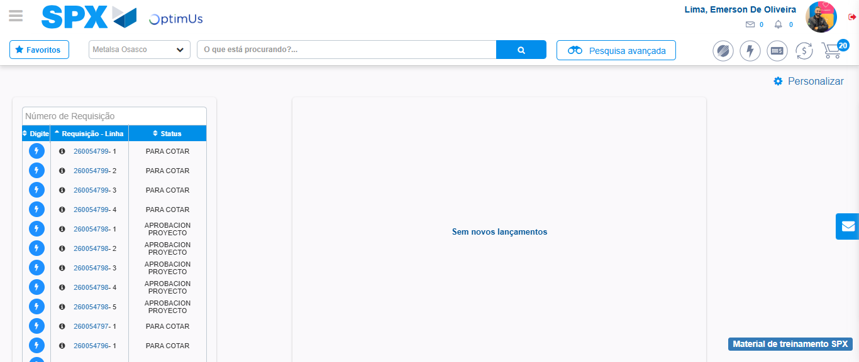Image file-name: QC_Testing-tc006_SPX_Dev5_Crear_Requisicion_Spot_Tipo_Cobro_Proyect_Urgent-1787008981320

Step 8 - Log Out : Log Out SPX
Image file-name: QC_Testing-tc006_SPX_Dev5_Crear_Requisicion_Spot_Tipo_Cobro_Proyect_Urgent-1787008981579

